Full name: | Sherwin Stany Dcosta
Batch: | MS FSD DEC 2021 Cohort 1
Project Title: | Online Test Application
Project Submission Date: | July 5, 2022

How to use and general overview of Online Test Application:

- There are two separate dashoboards.
- User and Admin dashboard.
- In admin page we can create ,update delete and add quiz .
- Admin can also create categories for the quiz.
- In user page, user can attend the quiz provided by the admin.
- After sucuccesfully attempting the quiz user can review and can see the total marks obtained by them.
- In below you will get the detailed instruction on how to create admin quizzes and categories using dashboard

Online Test Application Login Page

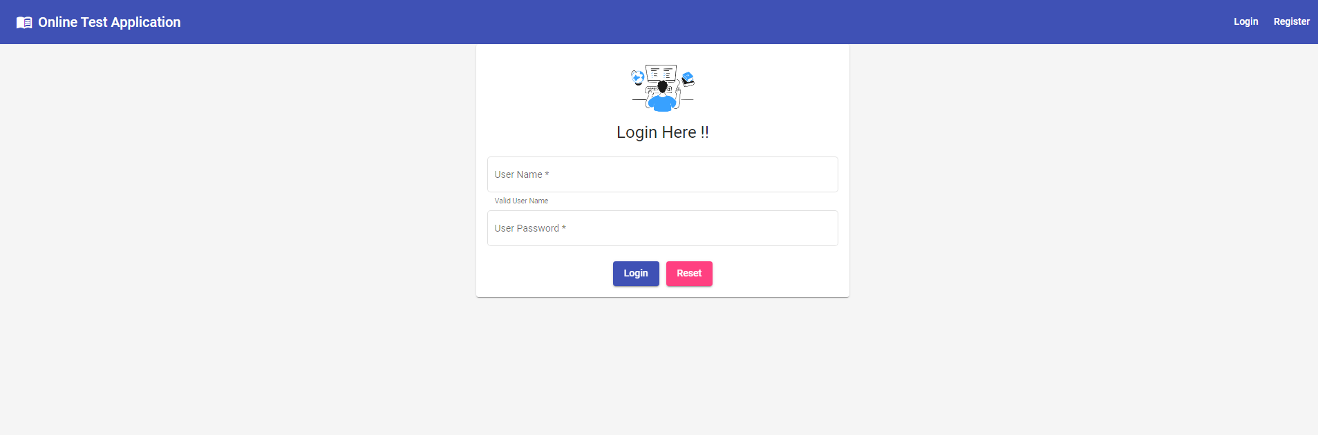
Admin Dashboard

- Admin can only be registered from the backend on the main application
- I have already provided the login details for the admin in backend.
- Please use the following credintials for the login :
- Username: Jerald
- Password: jerald02

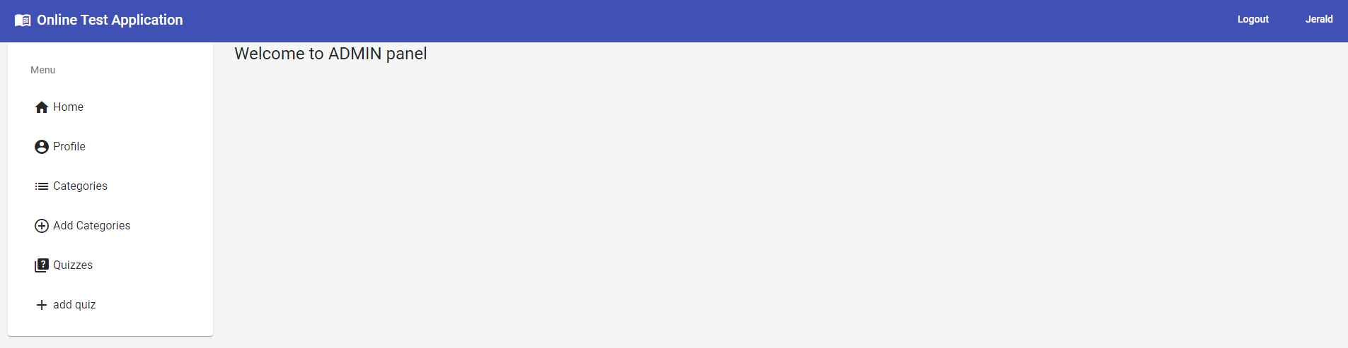

- Click on profile to view the profile of the admin

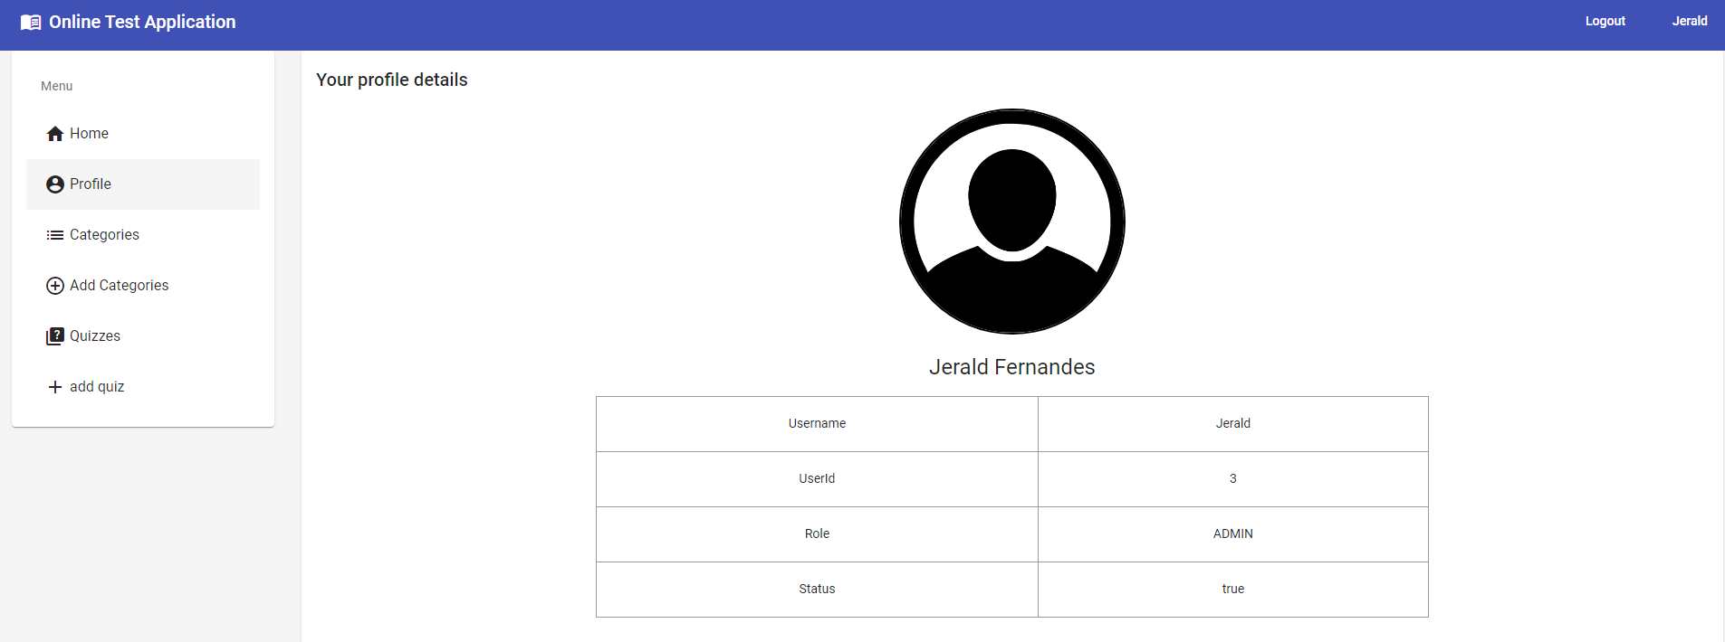

- On category tab admin can add or delete categories. And it also shows the categories already created by the admins

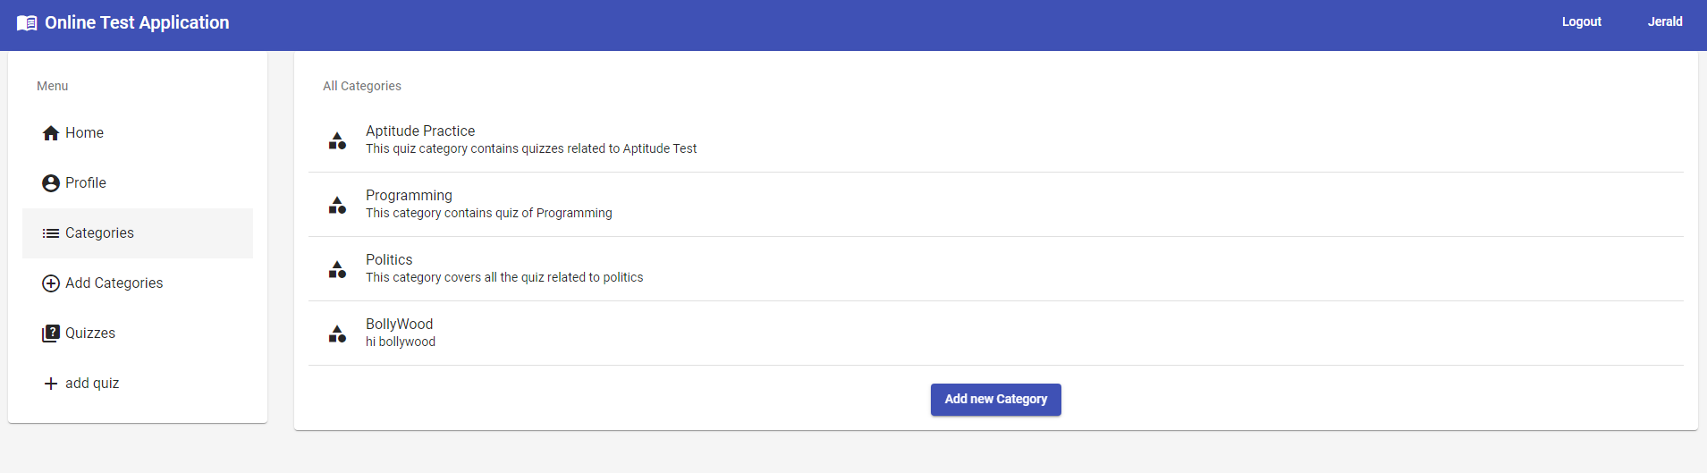
- Add new category

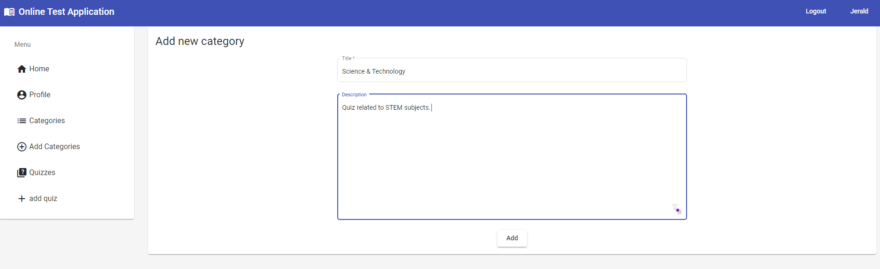

- On quiz tab admin can add and view the quizzes that were already

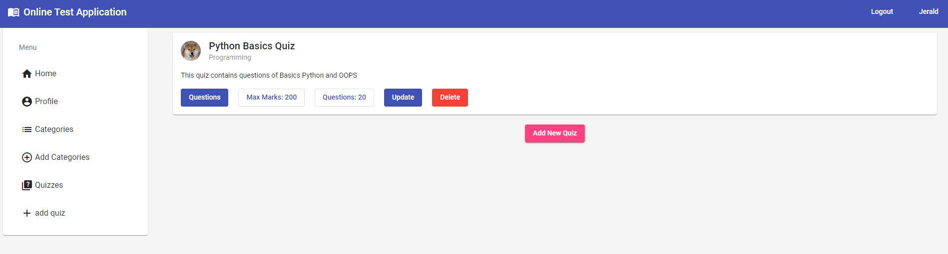
- On clicking add new quiz you will get this form . Fill in the details to create new quiz

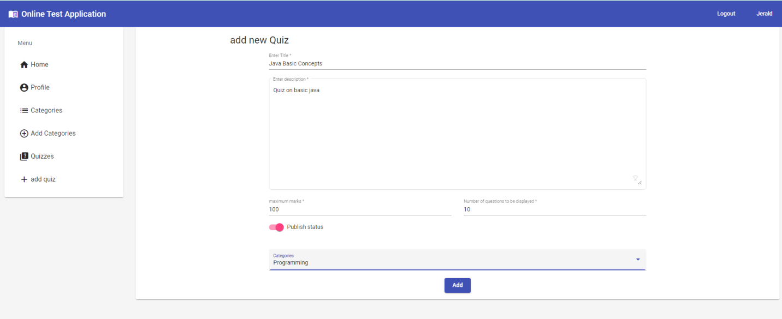



- By going to the quizzes tab and cliking on the questions button to add the question to the quizzes

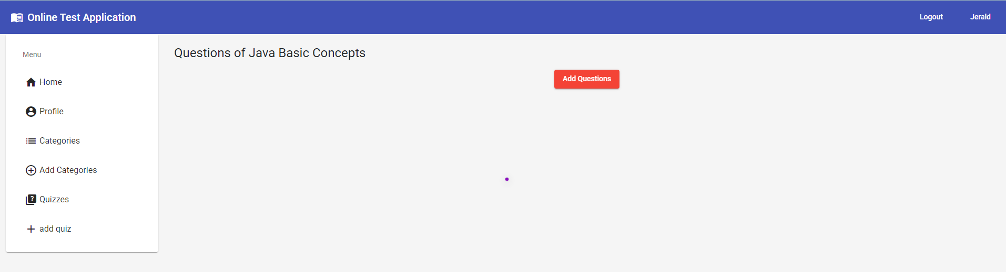

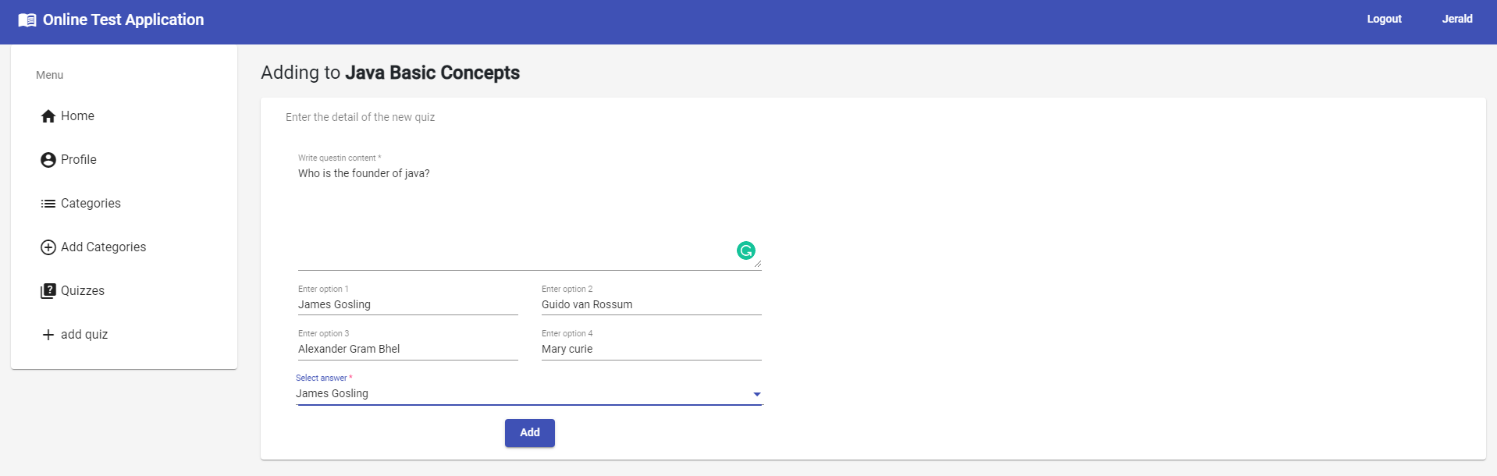
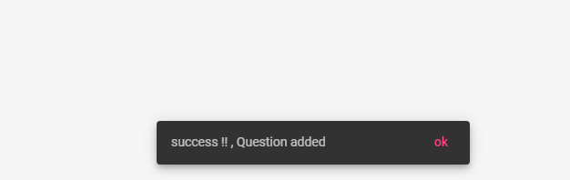
User Dashboard

REGISTRATION :

- To use it as user . First you have to register yourself and attained the quiz
- To register yourself as a user click on register
- Fill up the necessary details
- Then go to the login page

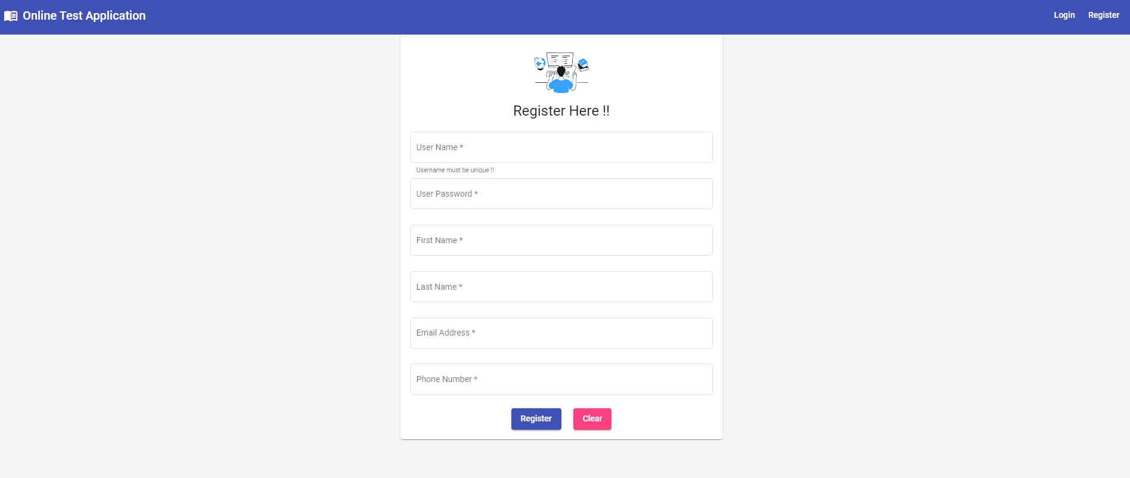
After successfully registering it will show up the message

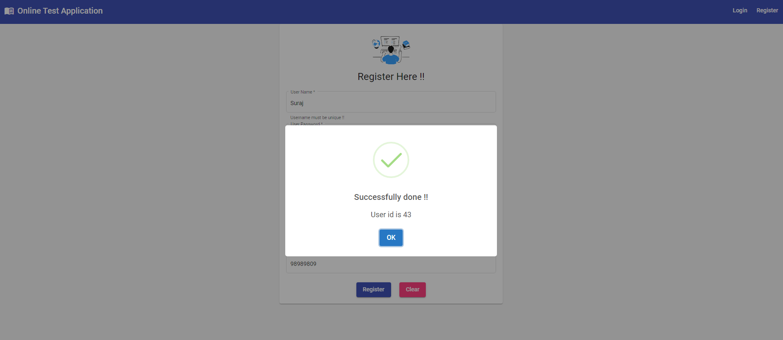

Login with the details provided before

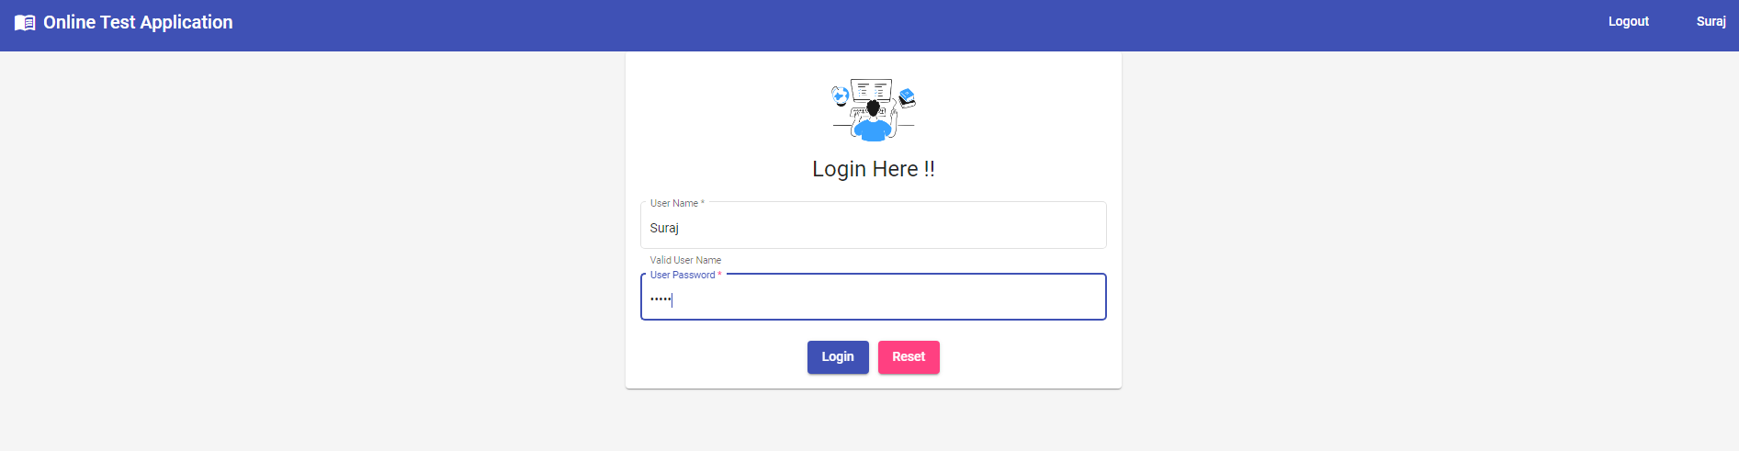
After succesfully logining the page. The user home page will be shown

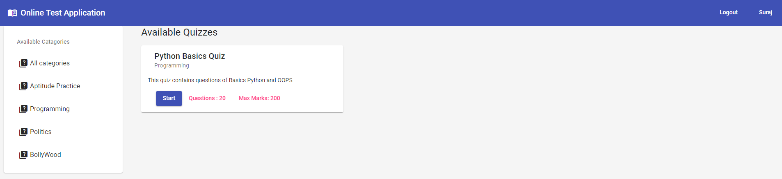
‘

Click on start button to attempt the quiz
This section shows the categories of the quiz

Answer the quiz

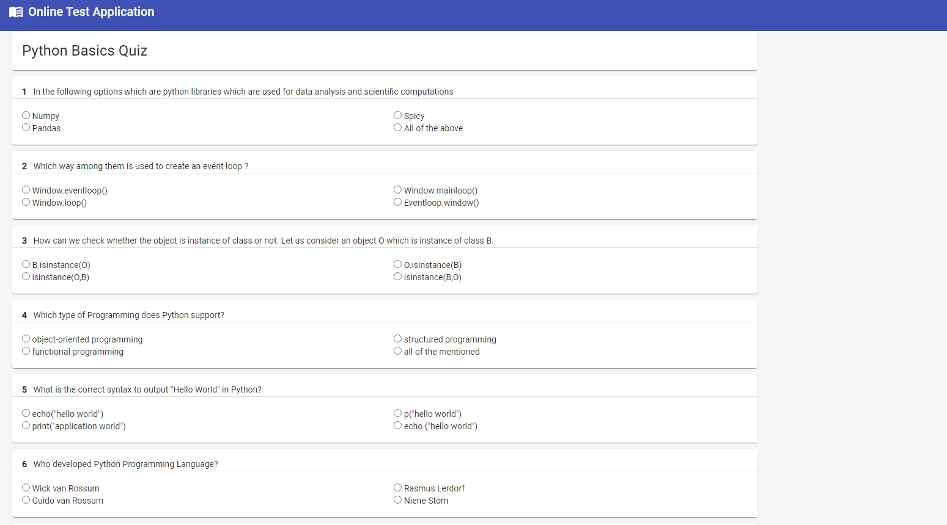

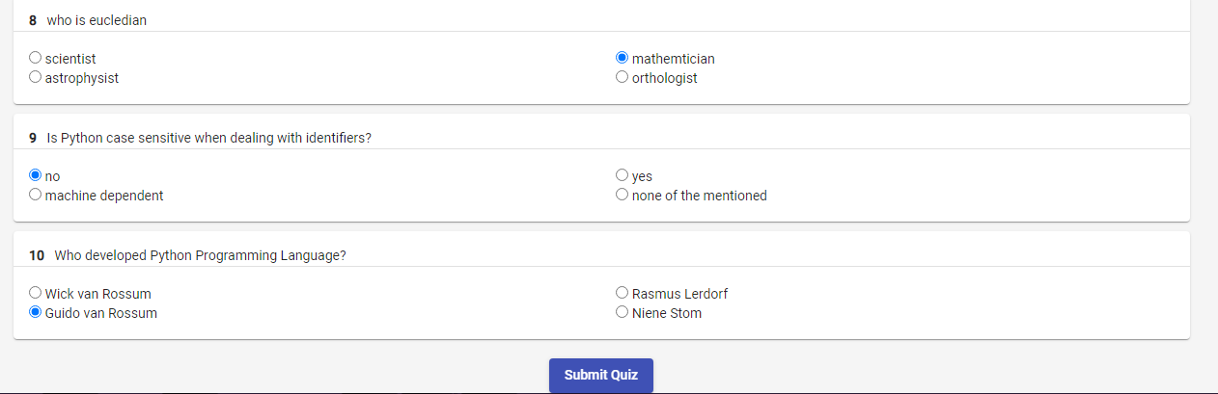

Click on submit button to submit the quiz
After submitting the quiz you can review the answers

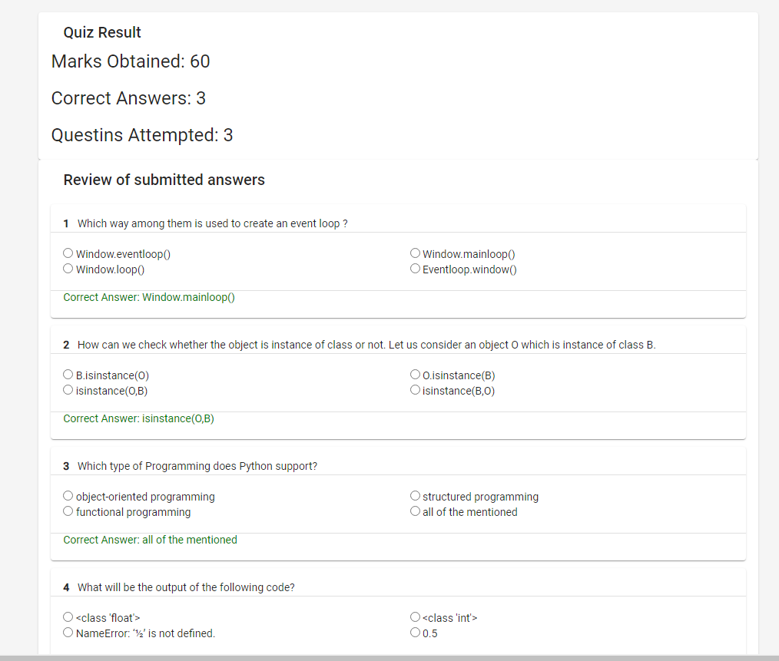

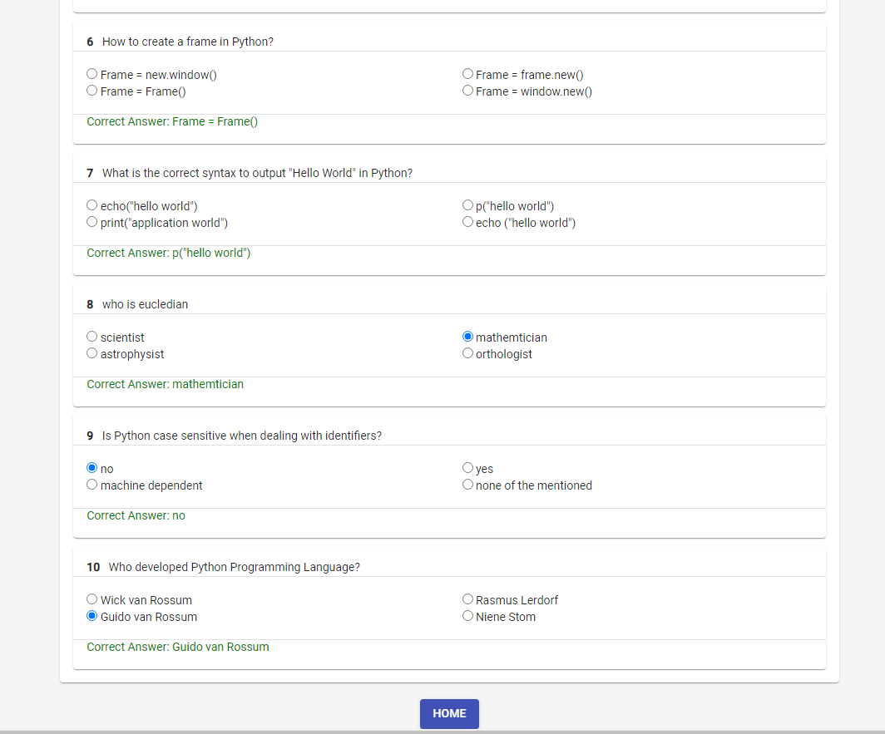

Click on home button to go back to the dashboard

How to run the application?

Steps to take before starting the server on spring boot:

- Make sure to do necessary changes on the application.properties file

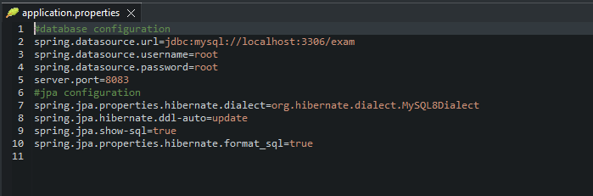

- Create the database on the MySQL.

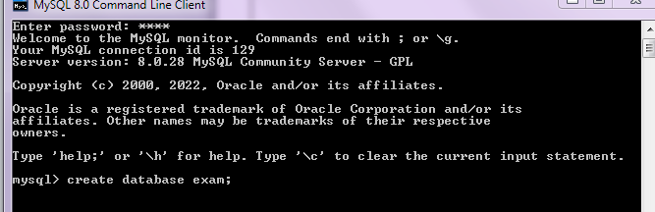

- To run the Angular application run type this coomand:

ng serve –o

Core Concepts –
Core concept: Java programming Language
Backend - Spring Boot, mySql, Hibernate, Spring security, JWT
Frontend – Angular, Bottstrap, Material UI, HTML, CSS.

Linked to the Github Account –

